Sennheiser spotlights better audio for modern creators, from podcast desks to documentary shoots
Audio solutions like the MKE 400, Profile USB Microphone and Profile Wireless offer premium sound without the complexity

Wedemark, Germany, May 2026 – As podcasting, streaming and mobile filmmaking continue to shape how stories are told, strong audio can make the difference between content that is merely consumed and content that truly connects. Whether recording interviews at home, hosting a live stream, shooting short-form video or capturing stories on location, clear and reliable sound is what gives content its sense of professionalism, immediacy and trust.

At the same time, creator workflows are becoming more diverse and more fluid. The same person may be recording a podcast one day, live-streaming the next and filming on location the day after, often with limited time. In that environment, audio tools are judged on how easy they integrate into fast, flexible ways of working. For many creators, the challenge is not simply capturing better sound, but doing so without adding friction to the process.

Sennheiser has practical audio tools for today’s fast-moving creators. For podcasters and streamers, the Profile USB Microphone and Profile Streaming Set are designed to be set up quickly and easily, taking users from unboxing to on-air in minutes. The microphone connects directly to a computer or tablet via USB-C, with controls for gain, headphone monitoring and mix placed directly on the microphone for a straightforward, app-free set-up. For creators who want a more flexible layout and optimal positioning, the Profile Streaming Set adds a boom arm with self-locking joint and integrated cable management.

A boom arm solution is the best choice for optimally positioning the mic

Content creation is not confined to the desk. Many creators are filming on location, working solo and producing everything from social content and branded videos to documentaries and independent films. In these situations, compact directional microphones can make a major difference.

Interviewing on location with the Sennheiser MKE 400

Sennheiser’s MKE 400 has already proven its value in real-world filmmaking. In recent productions by mobile cinematographer Cassius Rayner, the compact microphone was used in the award-winning documentary My Little Heart and short-film work such as The Missing, helping support focused, high-quality audio within a lightweight, mobile workflow. With its directional pick-up, built-in windscreen and integrated shock mount, the mic is ideal for creators who need better sound without adding bulk or complexity.

For content creators who need greater flexibility when working on the move, Sennheiser’s Profile Wireless is an easy-to-use solution for capturing audio in dynamic shooting environments. Available as a one- or two-channel system, Profile Wireless is well suited to interviews, mobile filmmaking and social content production. Thanks to the latest firmware update, Bluetooth functionality has been added to this compact microphone system, making it pairable with mobile phones, laptops or tablets that offer high-quality Bluetooth LE Audio (LC3 codec) or Bluetooth Classic.

The Profile Wireless clip-on mic can be directly connected to mobile phones with Bluetooth functionality | 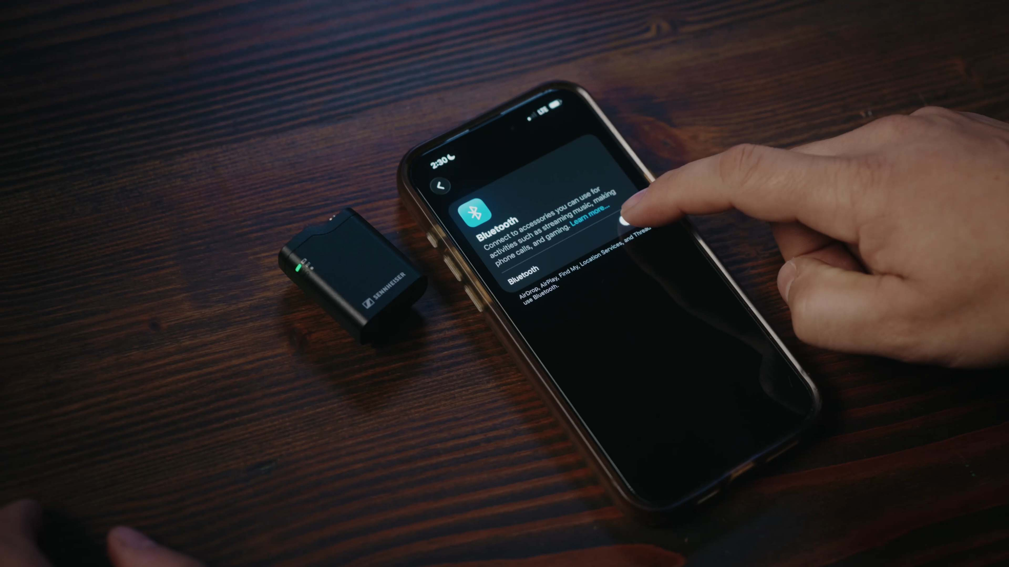

“Whether someone is launching a podcast, refining their livestream setup or filming stories on location, good audio is one of the quickest ways to elevate content,” says Hendrik Millauer, product manager at Sennheiser. “What creators increasingly want is professional sound without unnecessary complication. That is exactly where solutions like the Profile USB Microphone, MKE 400 and Profile Wireless come in, as they are designed to support the creative process, not slow it down.”

To help creators improve their sound this season, Sennheiser will run a series of limited-time promotions across participating regions, including Americas, EMEA, Greater China, South Korea, Southeast Asia, Australia/New Zealand and India. During May, the Profile USB Microphone and Profile Streaming Set will be available at promotional pricing at participating dealers. During June, the MKE 400 and MKE 400 Mobile Kit will follow with reduced pricing. In July, the Profile Wireless one-channel system will be on promotion. Exact regional timing, pricing and dealer participation may vary.

To support creators looking to improve their audio, Sennheiser runs a series of limited-time promotions at participating dealers

(Ends)

The high-resolution images accompanying this media release plus additional images can be downloaded here.

About the Sennheiser brand
We live and breathe audio. We are driven by the passion to create audio solutions that make a difference. Building the future of audio and bringing remarkable sound experiences to our customers – this is what the Sennheiser brand has represented for 80 years. While professional audio solutions such as microphones, meeting solutions, streaming technologies and monitoring systems are part of the business of Sennheiser electronic SE & Co. KG, the business with consumer devices such as headphones, soundbars and speech-enhanced hearables is operated by Sonova Holding AG under the license of Sennheiser.
www.sennheiser.com
www.sennheiser-hearing.com

